Question.

Design windows form that contain 3 radio buttons to display- area of circle, area of triangle, volume of cube.

On selection of radio button appropriate form should be displayed for taking input from user for further calculations.

Result should be displayed on another form.

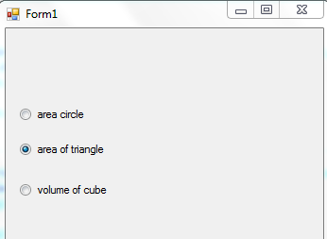

Public Class Form1

Private Sub btncircle_CheckedChanged(ByVal sender As System.Object, ByVal e As System.EventArgs) Handles btncircle.CheckedChanged

If btncircle.Checked = True Then

FrmCircle.Show()

Else

FrmCircle.Hide()

End If

End Sub

Private Sub btntriangle_CheckedChanged(ByVal sender As System.Object, ByVal e As System.EventArgs) Handles btntriangle.CheckedChanged

If btntriangle.Checked = True Then

FrmTriangle.Show()

Else

FrmTriangle.Hide()

End If

End Sub

Private Sub btncube_CheckedChanged(ByVal sender As System.Object, ByVal e As System.EventArgs) Handles btncube.CheckedChanged

If btncube.Checked = True Then

FrmCube.Show()

Else

FrmCube.Hide()

End If

End Sub

End Class

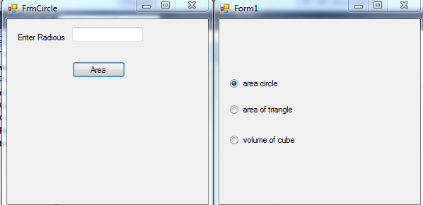

Public Class FrmCircle

Private Sub btnCircleArea_Click(ByVal sender As System.Object, ByVal e As System.EventArgs) Handles btnCircleArea.Click

Dim radious, area As Double

radious = CDbl(txtCircleRadious.Text)

area = 3.14D * radious * radious

FrmResult.lblResult.Text = "Area of circle is: " & area.ToString

FrmResult.Show()

Me.Hide()

End Sub

End Class

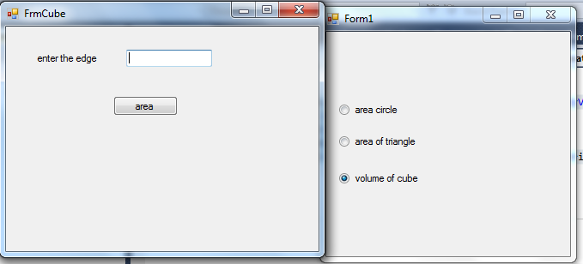

Public Class Frmtcube

Private Sub Button1_Click(ByVal sender As System.Object, ByVal e As System.EventArgs) Handles Button1.Click

Dim edge, volume As Double

edge = CDbl(TextBox1.Text)

volume = edge * edge * edge

FrmResult.lblResult.Text = "Volume of cube is: " & volume.ToString

FrmResult.Show()

Me.Hide()

End Sub

End Class

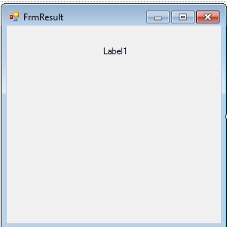

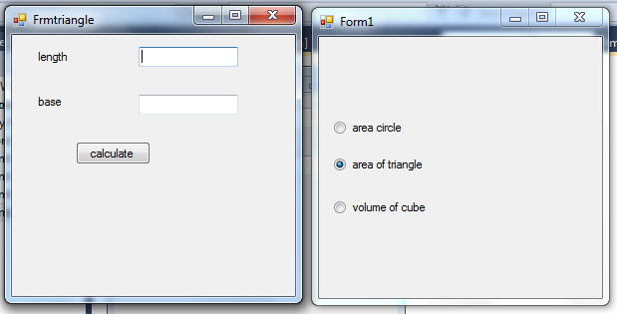

Public Class Frmtriangle

Private Sub Btnareatriangl_Click(ByVal sender As System.Object, ByVal e As System.EventArgs) Handles Btnareatriangl.Click

Dim length, base, area As Double

length = CDbl(TextBox1.Text)

base = CDbl(TextBox1.Text)

area = 0.5 * length * base

FrmResult.lblResult.Text = "Area of Triangle is: " & area.ToString

FrmResult.Show()

Me.Hide()

End Sub

End Class